

**Project Report**

**Topic**

“**Parallel Processing of Algorithms**”

**BY**

Awesh Kumar

ID:**21k-4526**

Hussain Malik

ID:**21K-4576**

**SUBMITTED TO**

Respected Sir Dr. Ghufran Ahmed

**Date Submitted: 15th of May 2023Project Introduction**

This project is about determining the most efficient programming technique out of the following three: Serial, OpenMp, and pthreads. This is done by experimenting each of these techniques on the following three sorting algorithms: Binary-Insertion Sort, Selection Sort, and Cocktail Sort. The serial, obviously, falls under the sequential programming, while the other two are used to achieve Parallel Programming.

**Project GOAL**

In this project, we aim to discover the most efficient technique which is done by executing programs of which each contain an array, with unsorted elements, and using a timer to record the sorting time of each technique.

**Codes:**

**Selection Sort:**

**Serial:**

#include <stdio.h>

#include <time.h>

#include <wait.h>

#include<sys/wait.h>

#include <stdlib.h>

#include<unistd.h>

#include<sys/time.h>

clock_t ticks;

struct timeval stop, start;

void selectionSort(int* A, int n);

void swap(int* a, int* b);

void display(int* arr, int n);

int main(){

time_t t;

int number, iter =0, find;

srand((unsigned) time(&t));

printf("\nEnter the Size of the Array: ");

scanf("%d", &number);

int *Arr = (int *)malloc( number * sizeof(int));

for(; iter<number; iter++){

Arr[iter] = rand() % 100;

}

double bstart = clock();

gettimeofday(&start, NULL);

selectionSort(Arr, number);

gettimeofday(&stop, NULL);

double bstop = clock();

display(Arr, number);

FILE* fp;

fp = fopen("Timings.txt", "a");

fprintf(fp, "Serial Burst Time: %lf\n",difftime(bstop,bstart));

fprintf(fp, "Serial Execution Time: %lu\n\n\n", (stop.tv_sec - start.tv_sec) * 1000000 + stop.tv_usec - start.tv_usec);

fclose(fp);

}

void display(int* arr, int n){

printf(“\nSorted Array\n”)’

for(int i = 0; i<n; i++)

{

if(i != n - 1)

{

printf("%d , ", *(arr + i));

}

else

printf("%d \n", *(arr + i));

}

}

void selectionSort(int* A, int n)

{

for(int startpos =0; startpos < n-1; startpos++){

int maxpos = startpos;

for(int i=startpos +1; i< n; ++i){

if(A[i] < A[maxpos]){

maxpos = i;

}

}

if(maxpos != startpos)

swap(&A[startpos], &A[maxpos]);

}

}

void swap(int* a, int* b){ int temp = *a; *a = *b; *b = temp; }

**Output Screen Shot**

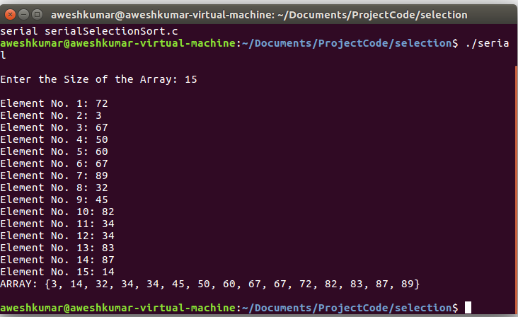

**Multi-threading (Pthreads)**:

#include <stdio.h>

#include <time.h>

#include <wait.h>

#include<sys/wait.h>

#include <stdlib.h>

#include<unistd.h>

#include<pthread.h>

#include<sys/time.h>

//time_t start, stop;

struct timeval stop, start;

clock_t ticks;

int linearSearch(int* A, int n, int tos);

void* selectionSort();

void swap(int* a, int* b);

void* merge(void* args);

void display(int* arr, int n);

#define MAX_THREAD 2

struct sortingArgs{

int *ptr;

int size;

int start, end;

}FinalArgs;

int main(){

time_t t;

srand((unsigned) time(&t));

pthread_t threads[MAX_THREAD];

int number, iter =0;

struct sortingArgs Args;

printf("\nEnter the Size of the Array: ");

scanf("%d", &number);

Args.size = number;

Args.start = 0;

Args.end = number/2;

int Arr[number];

Args.ptr = (int *)calloc( Args.size, Args.size * sizeof(int));

for(; iter<number; iter++){

*(Args.ptr + iter) = rand() % 100;

}

double bstart = clock();

gettimeofday(&start, NULL);

pthread_create(&threads[0], NULL, selectionSort, &Args);

pthread_join(threads[0], NULL);

Args.start = number/2 + 1;

Args.end = number;

pthread_create(&threads[1], NULL, selectionSort, &Args);

pthread_join(threads[1], NULL);

pthread_create(&threads[0], NULL, merge, &Args);

pthread_join(threads[0], NULL);

gettimeofday(&stop, NULL);

double bstop = clock();

Args.ptr = FinalArgs.ptr;

display(FinalArgs.ptr, number);

FILE* fp;

fp = fopen("Timings.txt", "a");

fprintf(fp, "Multi-threading Burst Time: %lf\n",difftime(bstop,bstart));

fprintf(fp, "Multi-threading Execution Time: %lu\n\n\n",(stop.tv_sec - start.tv_sec) * 1000000 + stop.tv_usec - start.tv_usec);

fclose(fp);

}

void* selectionSort(void* input)

{

struct sortingArgs *Arg = (struct sortingArgs*) input;

int n = Arg->end;

int s = Arg->start;

for(int startpos = s; startpos < n-1; startpos++){

int maxpos = startpos;

for(int i=startpos +1; i< n; ++i){

if(Arg->ptr[i] < Arg->ptr[maxpos])

maxpos = i;

}

if(maxpos != startpos)

swap(&Arg->ptr[startpos], &Arg->ptr[maxpos]);

}

pthread_exit(0);

}

void* merge(void* args)

{

struct sortingArgs *Arg = (struct sortingArgs*) args;

FinalArgs.size = Arg->size;

FinalArgs.ptr = (int *)calloc( FinalArgs.size, FinalArgs.size * sizeof(int));

int i = 0, j = Arg->size/2 + 1, k=0;

for(; i <(Arg->size/2 + 1); k++)

{

if(Arg->ptr[i] < Arg->ptr[j] || j>= Arg->size)

{

FinalArgs.ptr[k] = Arg->ptr[i];

i++;

}

else

{

if(j<Arg->size)

{

FinalArgs.ptr[k] = Arg->ptr[j];

j++;

}

}

}

while(j < Arg->size)

{

FinalArgs.ptr[k] = Arg->ptr[j];

k++;

j++;

}

//pthread_exit(0);

}

void swap(int* a, int* b){

int temp = *a;

*a = *b;

*b = temp;

}

void display(int* arr, int n){

printf("\nSorted Array\n");

for(int i = 0; i<n; i++)

{

if(i != n - 1)

{

printf("%d , ", *(arr + i));

}

else

printf("%d \n", *(arr + i));

}

}

**Output Screen Shot**

**OpenMp:**

#include <stdio.h>

#include <time.h>

#include <wait.h>

#include<sys/wait.h>

#include <stdlib.h>

#include<unistd.h>

#include<sys/time.h>

struct timeval stop, start;

clock_t ticks;

int linearSearch(int* A, int n, int tos);

void selectionSort(int* A, int n);

void swap(int* a, int* b);

void display(int* arr, int n);

int main(){

time_t t;

int number, iter =0, find;

srand((unsigned) time(&t));

printf("\nEnter the Size of the Array: ");

scanf("%d", &number);

int *Arr = (int *)malloc( number * sizeof(int));

for(; iter<number; iter++){

Arr[iter] = rand() % 100;

}

//time(&start);

double bstart = clock();

gettimeofday(&start, NULL);

selectionSort(Arr, number);

//time(&stop);

gettimeofday(&stop, NULL);

double bstop = clock();

display(Arr, number);

FILE* fp;

fp = fopen("Timings.txt", "a");

fprintf(fp, "OpenMP Burst Time: %lf\n",difftime(bstop,bstart));

fprintf(fp, "OpenMP Execution Time: %lu\n\n\n",(stop.tv_sec - start.tv_sec) * 1000000 + stop.tv_usec - start.tv_usec);

fclose(fp);

//printf("\nTIME: %lf ",difftime(stop,start));

}

void display(int* arr, int n){

printf("\nARRAY: {");

for(int i = 0; i<n; i++)

{

if(i != n - 1)

{

printf("%d, ", *(arr + i));

}

else

printf("%d}\n\n", *(arr + i));

}

}

void selectionSort(int* A, int n)

{

#pragma omp parallel for num_threads(2)

for(int startpos =0; startpos < n-1; startpos++){

int maxpos = startpos;

for(int i=startpos +1; i< n; ++i){

if(A[i] < A[maxpos]){

maxpos = i;

}

}

if(maxpos != startpos)

swap(&A[startpos], &A[maxpos]);

}

#pragma barrier

}

void swap(int* a, int* b){

int temp = *a;

*a = *b;

*b = temp;

}

**Output Screen Shot**

**Binary Insertion Sort:**

**Serial:**

#include <stdio.h>

#include <stdlib.h>

#include <sys/time.h>

#include <time.h>

#define SIZE 10

int num1[SIZE];

struct timeval Stop2,start2; // micro second resolution

int binary_search(int Num1,int left,int right)

{

if(right<=left)

{

if(Num1>num1[left])

{

return (left+1);

}

else

{

return left;

}

}

int mid_int=(left+right)/2;

if(Num1==num1[mid_int])

{

return (mid_int+1);

}

if(Num1>num1[mid_int])

{

return binary_search(Num1,mid_int+1,right);

}

else

{

return binary_search(Num1,left,mid_int-1);

}

}

void insertion_sort()

{

int num2,i,j,num3,k;

for(i=1;i<SIZE;i++)

{

j=i-1;

num3=num1[i];

num2=binary_search(num3,0,j);

while(j>=num2)

{

k=num1[j];

num1[j+1]=k;

j--;

}

j++;

num1[j]=num3;

}

}

void fill_array(int size) {

int i;

srand(time(NULL));

for (i=0; i<size; i++)

num1[i] = rand() % 100;

}

void file_create(double start,double stop)

{

FILE *ptr;

ptr=fopen("Sequencial_Insertion.txt","a+");

if(ptr==NULL)

{

printf("Unable to Open File");

exit(1);

}

else

{

double total= (double)(stop-start);

fprintf(ptr,"Time Taken(Burst Time): %lf\n",total);

fprintf(ptr,".comTime Taken(Clock Time): %lu\n",(Stop2.tv_sec-start2.tv_sec)*1000000+Stop2.tv_usec-start2.tv_usec);

}

fclose(ptr);

}

int main()

{

fill_array(SIZE);

double Start1=clock();

gettimeofday(&start2,NULL);

insertion_sort();

gettimeofday(&Stop2,NULL);

double stop1=clock();

for(int i=0;i<SIZE;i++)

{

printf("%d ",num1[i]);

}

file_create(Start1,stop1);

return 0;

}

**Output Screen Shot**

**Multi-threading (Pthreads):**

#include <stdio.h>

#include <stdlib.h>

#include <pthread.h>

#include <sys/time.h>

#define SIZE 10

int n1[SIZE];

int n2[SIZE];

struct timeval Stop2,start2;

typedef struct dim{

int start;

int end;

}limit;

typedef struct joined{

int Start;

int mid;

int End;

}join;

int binary_search(int move,int start,int end)

{

if (end<=start)

{

if(move > n1[end])

{

return (end + 1);

}

else

{

return end;

}

}

int mid = (start + end) / 2;

if(move == n1[mid])

{

return mid + 1;

}

if(move > n1[mid])

{

return binary_search(move,mid + 1, end);

}

return binary_search(move, start,mid - 1);

}

void* merge(void *args) {

struct joined *params = (struct joined*) args;

int begin = params->Start,

mid = params->mid,

end = params->End;

int i = begin, j = mid, tpos = begin;

while (i < mid && j <= end)

{

if (n1[i] < n1[j])

n2[tpos++] = n1[i++];

else

n2[tpos++] = n1[j++];

}

while (i <mid)

n2[tpos++] = n1[i++];

while (j <= end)

n2[tpos++] = n1[j++];

return NULL;

}

void* insertion(void *l)

{

limit *l1= (limit*)l;

int i=l1->start;

i++;

int j,k,move;

while(i<=l1->end)

{

j=i-1;

move=n1[i];

k=binary_search(move,l1->start,j);

while(j>=k)

{

n1[j+1]=n1[j];

j--;

}

n1[j+1]=move;

i++;

}

for(int i=l1->start;i<l1->end;i++)

{

printf("%d ",n1[i]);

}

printf("\n\n\n");

return NULL;

}

void fillarray(int size) {

int i;

srand(time(NULL));

for (i=0; i<size; i++)

n1[i] = rand() % 100;

}

void print_array(int list[], int size) {

int i;

for (i=0; i<size-1; i++)

printf("%d, ", list[i]);

printf("%d\n", list[i]);

}

void file_create(double start,double stop)

{

FILE *ptr;

ptr=fopen("PTHREAD_Insertion.txt","a+");

if(ptr==NULL)

{

printf("Unable to Open File");

exit(1);

}

else

{

double total= (double)(stop-start);

fprintf(ptr,"Time Taken(Burst Time): %lf\n",total);

fprintf(ptr,"Time Taken(Clock Time): %lu\n",(Stop2.tv_sec-start2.tv_sec)*1000000+Stop2.tv_usec-start2.tv_usec);

}

fclose(ptr);

}

int main()

{

fillarray(SIZE);

pthread_t t1,t2;

limit l1,l2;

l1.start=0;

l1.end=SIZE/2;

l2.start=l1.end+1;

l2.end=SIZE-1;

join j1;

j1.Start=l1.start;

j1.mid=l2.start;

j1.End=l2.end;

pthread_t m1;

double Start1=clock();

gettimeofday(&start2,NULL);

pthread_create(&t1,NULL,insertion,&l1);

pthread_create(&t2,NULL,insertion,&l2);

pthread_join(t1,NULL);

pthread_join(t2,NULL);

pthread_create(&m1,NULL,merge,&j1);

pthread_join(m1,NULL);

gettimeofday(&Stop2,NULL);

double stop1=clock();

print_array(n2,SIZE);

file_create(Start1,stop1);

return 0;

}

**Output Screen Shot**

**OpenMp:**

#include <stdio.h>

#include <stdlib.h>

#include <omp.h>

#include <time.h>

#include <sys/time.h>

#define Size 50

struct timeval Stop2,start2;

int n1[Size];

int n2[Size];

typedef struct dim{

int start;

int end;

}limit;

typedef struct joined{

int Start;

int mid;

int End;

}join;

int binary_search(int move,int start,int end)

{

if (end <= start)

{

if(move > n1[end])

{

return (end + 1);

}

else

{

return end;

}

}

int mid = (start + end) / 2;

if(move == n1[mid])

{

return mid + 1;

}

if(move > n1[mid])

{

return binary_search(move,mid + 1, end);

}

return binary_search(move, start,mid - 1);

}

void* merge(void *args) {

//unpack parameters

struct joined *params = (struct joined*) args;

int begin = params->Start,

mid = params->mid,

end = params->End;

int i = begin, j = mid, tpos = begin;

while (i < mid && j <= end)

{

if (n1[i] < n1[j])

n2[tpos++] = n1[i++];

else

n2[tpos++] = n1[j++];

}

//still elements left over in first list. copy over

while (i <=mid)

n2[tpos++] = n1[i++];

//still elements left over in first list. copy over

while (j <= end)

n2[tpos++] = n1[j++];

return NULL;

}

void* insertion(void *l)

{

limit *l1= (limit*)l;

int i=l1->start;

i++;

int j,k,move;

while(i<=l1->end)

{

j=i-1;

move=n1[i];

k=binary_search(move,l1->start,j);

while(j>=K)

{

n1[j+1]=n1[j];

j--;

}

n1[j+1]=move;

i++;

}

return NULL;

}

void fill_array(int size) {

int i;

srand(time(NULL));

for (i=0; i<size; i++)

n1[i] = rand() % 100;

}

void print_array(int *list, int size) {

int i;

for (i=0; i<size-1; i++)

printf("%d, ", list[i]);

printf("%d\n", list[i]);

}

void file_create(double start,double stop)

{

FILE *ptr;

ptr=fopen("OPENMP_Insertion.txt","a+");

if(ptr==NULL)

{

printf("Unable to Open File");

exit(1);

}

else

{

double total= (double)(stop-start);

fprintf(ptr,"Time Taken(Burst Time): %lf\n",total);

fprintf(ptr,"Time Taken(Clock Time): %lu\n",(Stop2.tv_sec-start2.tv_sec)*1000000+Stop2.tv_usec-start2.tv_usec);

}

fclose(ptr);

}

int main()

{

fill_array(Size);

limit l1,l2;

l1.start=0;

l1.end=Size/2;

l2.start=l1.end+1;

l2.end=Size-1;

join j1;

j1.Start=l1.start;

j1.mid=l2.start;

j1.End=l2.end;

double Start1=clock();

gettimeofday(&start2,NULL);

#pragma omp parallel sections num_threads(2)

{

#pragma omp section

{

insertion(&l1);

}

#pragma omp section

{

insertion(&l2);

}

}

merge(&j1);

gettimeofday(&Stop2,NULL);

double stop1=clock();

print_array(n2,Size);

file_create(Start1,stop1);

return 0;

}

**Output Screen Shot**

**Cocktail Sort**

**Serial:**

#include<stdio.h>

#include<time.h>

#include<sys/time.h>

#include<stdlib.h>

void Cocktail_Sort(int *A,int size)

{

int start=0;

int end=size-1;

while(start!=(size/2))

{

for(int i=start;i<end;i++)

{

if( *(A+i)>*(A+(i+1)))

{

int temp=*(A+i);

*(A+i)=*(A+(i+1));

*(A+(i+1))=temp;

}

}

for(int j=end-1;j>=start;j--)

{

if(*(A+j)<*(A+(j-1)))

{

int temp=*(A+j);

*(A+(j))=*(A+(j-1));

*(A+(j-1))=temp;

}

}

start++;

end--;

}

}

void Filling(double Start,double End,double Total)

{

FILE *ptr;

ptr=fopen("Project_Times.txt","a+");

if(ptr==NULL)

{

printf("Unable to Open File");

exit(1);

}

else

{

double total= (double)(End-Start)/(double)CLOCKS_PER_SEC;;

fprintf(ptr,"Burst Time Taken By Sequencial_Cocktail_Sort is %lf\n",total);

fprintf(ptr,"Total Time Taken By Sequencial_Cocktail_Sort is %lf\n",Total);

}

fclose(ptr);

}

int main(void)

{

srand(time(NULL));

int n;

struct timeval stop, start;

printf("Enter The Size of Array: ");

scanf("%d",&n);

int *ptr=(int *) calloc(n,sizeof(int));

printf("Enter The Elements Array\n");

for(int i=0;i<n;i++)

{

*(ptr+i)=rand()%n;

}

double Start=clock();

gettimeofday(&start, NULL);

Cocktail_Sort(ptr,n);

gettimeofday(&stop, NULL);

double End=clock();

printf("Sorted Array: ");

for(int i=0;i<n;i++)

{

printf("%d ",(ptr[i]));

}

printf("\n");

double Total=(double)((stop.tv_sec - start.tv_sec) * 1000000 + stop.tv_usec - start.tv_usec);

Filling(Start,End,Total);

}

**Output Screen Shot**

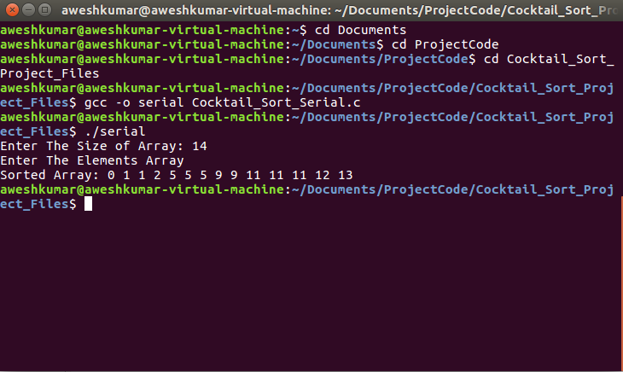

**Multi-threading (Pthreads):**

#include<stdio.h>

#include<time.h>

#include<sys/time.h>

#include<stdlib.h>

#include<pthread.h>

struct array

{

int *ptr;

long int size;

}Array,Final_Array;

struct Time

{

double Start,End;

}Execution;

struct timeval stop, start;

void* Cocktail_Sort_Down(void *args )

{

int start=(Array.size/2+1);

int end=Array.size-1;

int i;

while(start<end)

{

for(i=start;i<end;i++)

{

if(Array.ptr[i]>Array.ptr[i+1])

{

int temp=Array.ptr[i];

Array.ptr[i]=Array.ptr[i+1];

Array.ptr[i+1]=temp;

}

}

for(i=end-1;i>start;i--)

{

if(Array.ptr[i]<Array.ptr[i-1])

{

int temp=Array.ptr[i];

Array.ptr[i]=Array.ptr[i-1];

Array.ptr[i-1]=temp;

}

}

start++;

end--;

}

pthread_exit(0);

}

void* Cocktail_Sort_Up(void *args)

{

int start=0;

int end=Array.size/2;

int i;

while(start<end)

{

for(i=start;i<end;i++)

{

if(Array.ptr[i]>Array.ptr[i+1])

{

int temp=Array.ptr[i];

Array.ptr[i]=Array.ptr[i+1];

Array.ptr[i+1]=temp;

}

}

for(i=end-1;i>start;i--)

{

if(Array.ptr[i]<Array.ptr[i-1])

{

int temp=Array.ptr[i];

Array.ptr[i]=Array.ptr[i-1];

Array.ptr[i-1]=temp;

}

}

start++;

end--;

}

pthread_exit(0);

}

void* merge(void *args)

{

Final_Array.size=Array.size;

Final_Array.ptr=(int *) calloc(Final_Array.size,sizeof(int));

int i=0,j=Array.size/2+1,k=0;

for(;i<(Array.size/2+1);k++)

{

if(Array.ptr[i]<Array.ptr[j] || j>=Array.size)

{

Final_Array.ptr[k]=Array.ptr[i];

i++;

}

else

{

if(j<Array.size)

{

Final_Array.ptr[k]=Array.ptr[j];

j++;

}

}

}

while(j<Array.size)

{

Final_Array.ptr[k]=Array.ptr[j];

j++;

k++;

}

}

void* Filling(void *args)

{

FILE *ptr;

ptr=fopen("Project_Times.txt","a+");

if(ptr==NULL)

{

printf("Unable to Open File");

exit(1);

}

else

{

double total= (double)(Execution.End-Execution.Start)/(double)CLOCKS_PER_SEC;

double Total=(double)((stop.tv_sec - start.tv_sec) * 1000000 + stop.tv_usec - start.tv_usec);

fprintf(ptr,"Burst Time Taken By Multithreaded_Cocktail_Sort is %lf\n",total);

fprintf(ptr,"Time Taken By Multithreaded_Cocktail_Sort is %lf\n",Total);

}

fclose(ptr);

pthread_exit(0);

}

int main(void)

{

srand(time(NULL));

printf("Enter The Size of Array: ");

scanf("%ld",&Array.size);

Array.ptr=(int *) calloc(Array.size,sizeof(int));

printf("Enter The Elements Array\n");

for(int i=0;i<Array.size;i++)

{

*(Array.ptr+i)=rand()%Array.size;

}

pthread_t threads[2];

Execution.Start=clock();

gettimeofday(&start, NULL);

pthread_create(&threads[0],NULL,Cocktail_Sort_Up,NULL);

pthread_create(&threads[1],NULL,Cocktail_Sort_Down,NULL);

for(int i=0;i<2;i++)

{

pthread_join(threads[i],NULL);

}

pthread_create(&threads[0],NULL,merge,NULL);

pthread_join(threads[0],NULL);

gettimeofday(&stop, NULL);

Execution.End=clock();

pthread_create(&threads[1],NULL,Filling,NULL);

printf("Sorted Array: ");

for(int i=0;i<Array.size;i++)

{

printf("%d ",(Final_Array.ptr[i]));

}

printf("\n");

pthread_join(threads[1],NULL);

}

**Output Screen Shot**

**OpenMp:**

#include<stdio.h>

#include<time.h>

#include<sys/time.h>

#include<stdlib.h>

#include<omp.h>

void Cocktail_Sort(int *A,int size)

{

int start=0,end=size-1;

int swap=1;

int counter=0;

while(counter!=size/2+1)

{

#pragma omp parallel sections num_threads(2)

{

#pragma omp section

{

#pragma omp parallel for shared(A,swap,start)

for(int i=start;i<size/2;i+=2)

{

if( *(A+i)>*(A+(i+1)))

{

int temp=*(A+i);

*(A+i)=*(A+(i+1));

*(A+(i+1))=temp;

swap=1;

}

}

}

#pragma omp section

{

#pragma omp parallel for shared(A,swap)

for(int j=end;j>(size/2 +1);j-=2)

{

if(*(A+j)<*(A+(j-1)))

{

int temp=*(A+j);

*(A+(j))=*(A+(j-1));

*(A+(j-1))=temp;

swap=1;

}

}

}

}

(start==0)?start++:start--;

(end==size-1)?end--:end++;

counter++;

}

}

int* merge(int *P,int n)

{

int *FP=(int *) calloc(n,sizeof(int));

int i=0,j=n/2+1,k=0;

for(;i<=n/2;k++)

{

if(P[i]<P[j] || j>=n)

{

FP[k]=P[i];

i++;

}

else

{

if(j<n)

{

FP[k]=P[j];

j++;

}

}

}

while(j<n)

{

FP[k]=P[j];

j++;

k++;

}

return FP;

}

void Filling(double Start,double End,double Total)

{

FILE *ptr;

ptr=fopen("Project_Times.txt","a+");

if(ptr==NULL)

{

printf("Unable to Open File");

exit(1);

}

else

{

double total= (double)(End-Start)/(double)CLOCKS_PER_SEC;

fprintf(ptr,"Burst Time Taken By OpenMp_Cocktail_Sort is %lf\n",total);

fprintf(ptr,"Time Taken By OpenMp_Cocktail_Sort is %lf\n",Total);

}

fclose(ptr);

}

int main(void)

{

srand(time(NULL));

int n;

struct timeval stop, start;

printf("Enter The Size of Array: ");

scanf("%d",&n);

int *ptr=(int *) calloc(n,sizeof(int));

printf("Enter The Elements Array\n");

for(int i=0;i<n;i++)

{

*(ptr+i)=rand()%n;

}

double Start=clock();

gettimeofday(&start, NULL);

Cocktail_Sort(ptr,n);

int *fp=merge(ptr,n);

gettimeofday(&stop, NULL);

double End=clock();

printf("Sorted Array: ");

for(int i=0;i<n;i++)

{

printf("%d ",(fp[i]));

}

printf("\n");

double Total=(double)((stop.tv_sec - start.tv_sec) * 1000000 + stop.tv_usec - start.tv_usec);

Filling(Start,End,Total);}

**Output Screen Shot**

**Project Conclusion**

After executing the programs, the sorting times of each technique implemented on a sorting algorithm is compared. The technique which produces the lowest time is considered as the best technique, and the one which produces the highest time is considered as the worst. This is done for all three sorting algorithms.

**Comparative Graphs**

**Binary_Insertion Sort(Clock_Time)**

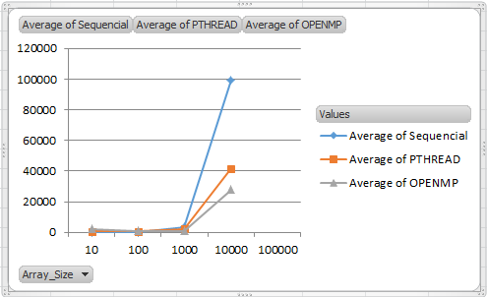

|  |  |  |  |
| --- | --- | --- | --- |
| **Array_Size** | **Serial** | **PTHREAD** | **OPENMP** |
| 10 | 7 | 647 | 2425 |
| 100 | 63 | 459 | 960 |
| 1000 | 3583 | 598 | 1017 |
| 10000 | 99172 | 78097 | 27861 |
| 100000 | 9247398 | 4290962 | 2216668 |

|  |  |  |  |
| --- | --- | --- | --- |
| **Array_Size** | **Sequencial** | **PTHREAD** | **OPENMP** |
| 10 | 3 | 709 | 2382 |
| 100 | 58 | 598 | 817 |
| 1000 | 3622 | 2288 | 1017 |
| 10000 | 99434 | 41588 | 27861 |
| 100000 | 9248780 | 2157261 | 2216668 |

**(Burst Time)**

**Selection Sort**

**(Clock_Time)**

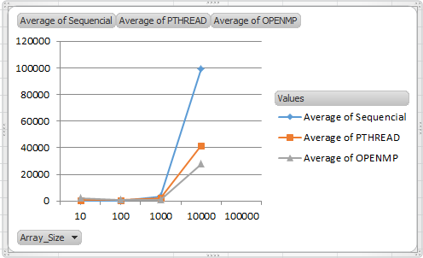

|  |  |  |  |
| --- | --- | --- | --- |
| **Array_Size** | **Serial** | **Pthread** | **OpenMp** |
| 10 | 1 | 321 | 97 |
| 100 | 33 | 360 | 167 |
| 1000 | 3375 | 1836 | 2813 |
| 10000 | 233583 | 174578 | 182367 |

|  |  |  |  |
| --- | --- | --- | --- |
| **Array_Size** | **Sequencial** | **PTHREAD** | **OPENMP** |
| 10 | 1 | 148 | 12 |
| 100 | 35 | 340 | 59 |
| 1000 | 2606 | 14240 | 2436 |
| 10000 | 210689 | 631466 | 194323 |
|  |  |  |  |

**(Burst_Time)**

|  |  |  |  |
| --- | --- | --- | --- |
| **Array_Size** | **SERIAL** | **PTHREAD** | **OPENMP** |
| 10 | 4 | 308 | 101 |
| 100 | 37 | 347 | 172 |
| 1000 | 5656 | 3815 | 2514 |
| 10000 | 160351 | 141579 | 94925 |

**Cocktail Sort**

**(Clock_Time)**

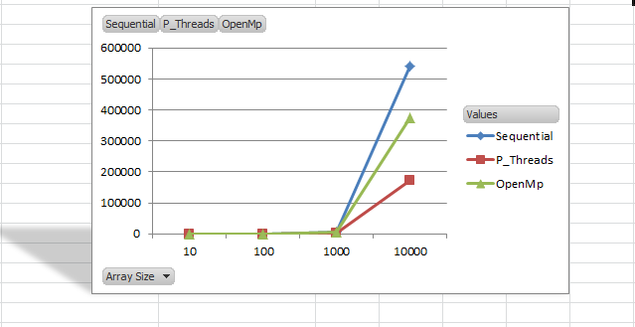

|  |  |  |  |
| --- | --- | --- | --- |
| Time Taken | Time Taken | Time Taken | Array Size |
| 1 | 450 | 125 | 10 |
| 32 | 731 | 269 | 100 |
| 4546 | 1929 | 39144 | 1000 |
| 541007 | 71912 | 419953 | 10000 |
| **Sequential** | **P_Threads** | **OpenMp** |  |

**(Burst_Time)**

|  |  |  |  |
| --- | --- | --- | --- |
| **Array_Size** | **Serial** | **Pthread** | **OpenMp** |
| 10 | 3 | 752 | 209 |
| 100 | 834 | 699 | 619 |
| 1000 | 4553 | 3218 | 3964 |
| 10000 | 573569 | 318419 | 509846 |

**=>**The above results show that the **primary factor of efficiency** is the size of the data. The smaller the data the better sequential performs. On the other hand, the larger the data the better PTHREAD and OPENMP performs. The second factor is the CPU burst time; the results show that depending on the algorithms, **sequential tends to consume more CPU** Burst time than parallel programming.